**All the resources for the course**

**Resources for The Complete Selenium WebDriver Course**

by [Nikolay Advolodkin](https://ultimateqa.com/author/qa-administrator87/) | Oct 29, 2017 | [Resources](https://ultimateqa.com/category/resources/) | [0 comments](https://ultimateqa.com/resources-complete-selenium-webdriver-course/#respond)

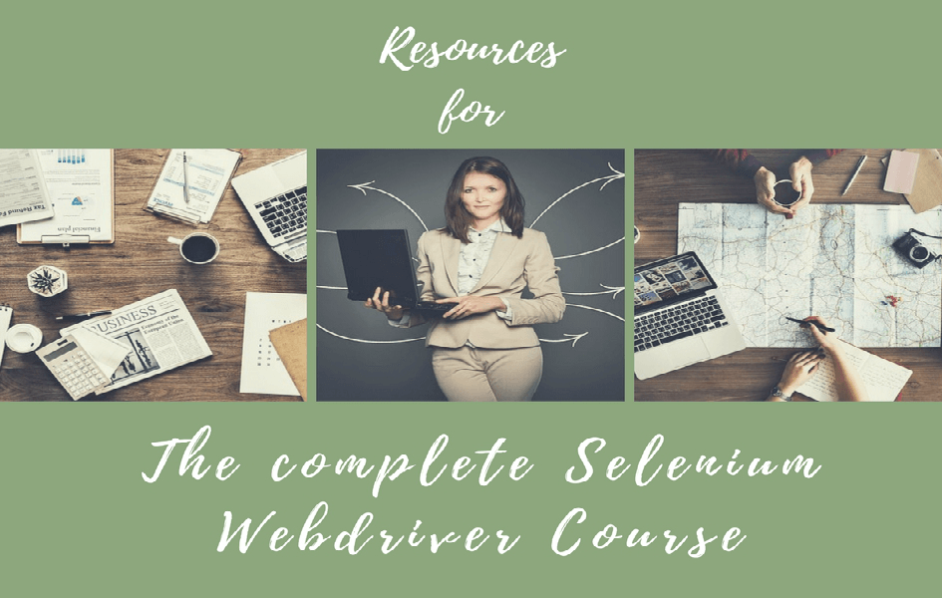

* All resources related to Complete Selenium Webdriver with C# – Build A Framework.

**Bookmark this page to help you throughout the course!**

[toc]

**Most Important Resources**

These are the resources that you will find the most used

* The [C# code solution](https://github.com/nadvolod/CSharpLesons) that we use to train for the C# section
* The [Selenium WebDriver code](https://github.com/nadvolod/LightPomFrameworkTutorial) solution that we use to train Selenium
* This [blog post](https://ultimateqa.com/common-selenium-webdriver-errors-fix/) that will resolve the majority of Selenium issues that you will face
* This[blog post](https://ultimateqa.com/errors-selenium-dotnet-masterclass/) addresses the most common errors students face while taking the course [Selenium Webdriver Masterclass with C#](https://www.udemy.com/course/selenium-with-c/?utm_source=adwords&utm_medium=udemyads&utm_campaign=LongTail_la.EN_cc.ROW&utm_content=deal4584&utm_term=_._ag_77879423894_._ad_428734577241_._kw__._de_c_._dm__._pl__._ti_dsa-1007766171032_._li_1001575_._pd__._&matchtype=b&gclid=EAIaIQobChMIvJi86Zrt6AIVDoKRCh18Mwq4EAAYASAAEgKktvD_BwE)

**Section 1 – Getting Started with C#**

* [Visual Studio](https://www.visualstudio.com/vs/community/)
* [Most common Selenium errors blog post](https://ultimateqa.com/common-selenium-webdriver-errors-fix/)
* [LightShot screen capture tool](https://app.prntscr.com/en/index.html)
* [How to install Parallels for Mac](https://www.youtube.com/watch?v=ARQ4sCyBsmk)
* [Parallels support docs](https://www.parallels.com/products/desktop/support/)
* [Framework code](https://github.com/nadvolod/LightPomFrameworkTutorial)

**Section 18 – Setting up Selenium WebDriver resources**

* [Selenium dotnet changelog](https://github.com/SeleniumHQ/selenium/blob/master/dotnet/CHANGELOG)
* [Selenium WebDriver Nuget package](https://www.nuget.org/packages/Selenium.WebDriver/)
* [ChromeDriver download](https://sites.google.com/a/chromium.org/chromedriver/)

**Section 19 – Locating Web Elements with WebDriver**

* [Visual Studio](https://www.visualstudio.com/vs/community/)
* [Selenium Webdriver version 3.0.1](https://www.nuget.org/packages/Selenium.WebDriver/3.0.1)
* [Chrome Driver v 2.26](https://chromedriver.storage.googleapis.com/index.html?path=2.26/)
* [Chrome Browser](https://www.google.com/chrome/browser/desktop/index.html?brand=CHBD&gclid=Cj0KCQjwzKPGBRCSARIsAAy9W4yGoSBdZLLMmCfFsFMKMw6yjj7pek3eEdPddyq6CrbJqsoBNiAq3KYaApe0EALw_wcB) – make sure your ChromeDriver supports this browser
* Websites for practice
  + [Main Practice Website](https://ultimateqa.com/automation/)
  + [QTP Practice Site](http://www.qtptutorial.net/automation-practice/)
* Extra resources
  + [HTML Documentation](https://www.w3schools.com/html/)
  + [Xpath Documentation](https://www.w3schools.com/xml/xpath_intro.asp)

**Topic – User Interactions**

A topic spans multiple sections

* [All resources](https://ultimateqa.com/resources-course-mouse-keyboard-actions-selenium-webdriver/)

**Topic – Implicit and Explicit Waits**

A topic spans multiple sections

* This is a [blog post](https://wp.me/p7absY-3Q) that clearly outlines the differences between the different waits
* Urls(these are the urls that we use for our tests, copy these somewhere for yourself)
  + Parent Page: <https://the-internet.herokuapp.com/dynamic_loading>
  + Page 1: [https://the-internet.herokuapp.com/dynamic\_loading…](https://the-internet.herokuapp.com/dynamic_loading/1)
  + Page 2: [https://the-internet.herokuapp.com/dynamic\_loading…](https://the-internet.herokuapp.com/dynamic_loading/2)
* [WebDriverWait class documentation](https://seleniumhq.github.io/selenium/docs/api/dotnet/html/T_OpenQA_Selenium_Support_UI_WebDriverWait.htm)
* [Implicit and Explicit wait recommendations from Selenium](http://www.seleniumhq.org/docs/04_webdriver_advanced.jsp)
* [ExpectedConditions class](https://seleniumhq.github.io/selenium/docs/api/dotnet/html/T_OpenQA_Selenium_Support_UI_ExpectedConditions.htm)

**Mastering Page Objects Section**

* [Source code](https://github.com/nadvolod/LightPomFrameworkTutorial/tree/master/PageObjects)
* [MsTest tests not executing on .NET Core error and how to fix it](http://bit.ly/MsTestExecError)
* [Automation anti-pattern of using complex data source](https://ultimateqa.com/automation-patterns-antipatterns/#excel)

**What will be covered in the next several sections?**

* [Ultimate QA Agile Practice App](https://ultimateqa.com/sample-application-lifecycle-sprint-1/)
* [Automation Practice online clothing store application](http://automationpractice.com/index.php)
* [Large and complicated automation practice page on Ultimate QA](https://ultimateqa.com/complicated-page/)

**Logging in test automation**

* Nlog wiki – <https://github.com/NLog/NLog/wiki/Tutorial>
* NLog logging levels – <https://github.com/NLog/NLog/wiki/Tutorial#log-levels>

**Creating Reports for Test Automation**

* Xtent Reports Docs Page – <http://extentreports.com/documentation/>
* .NET 3.0 Docs for Extent Reports – <http://extentreports.com/docs/versions/3/net/>

**Bonus Resources**

These are the resources that will take your automation to the next level and will allow you to get any job that you want.

* The [best dummy automation websites](https://ultimateqa.com/?s=best+automation+practice+sites) where you can actually practice test automation

My [favorite books](https://ultimateqa.com/best-software-testing-books/" \t "_blank) to improve your test automation skills